**Bash Module 5**

**Gokula Madhavan B**

**Sri Sairam Engineering college**

Advance topics in a function

1) Write a function add to add two numbers and call the function in another file.

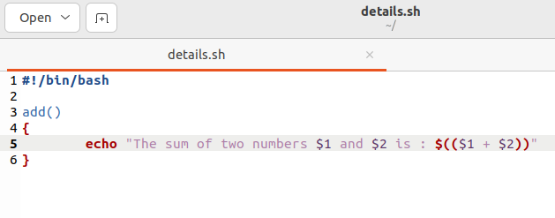

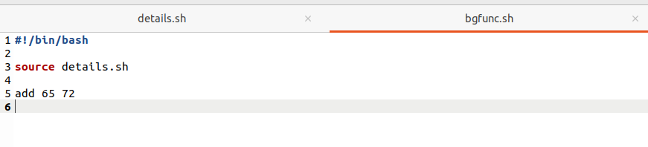

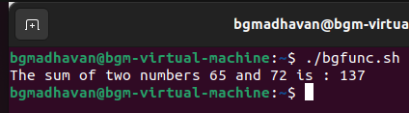

Recursive function

1. Write a program where the recursive function calculates the sum of N numbers

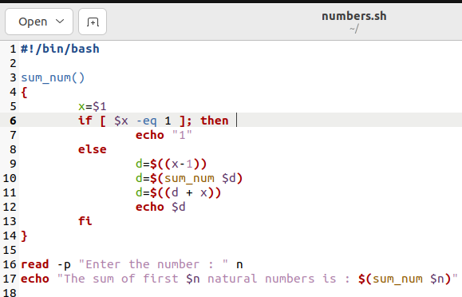

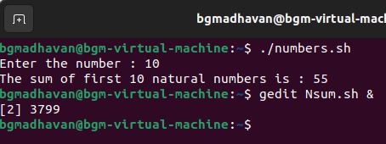

Basics of Redirection (error handling)

1) Write a program in any language like C, C++, Java.

2) And redirect the output or error to a new file.

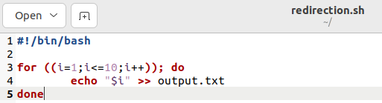

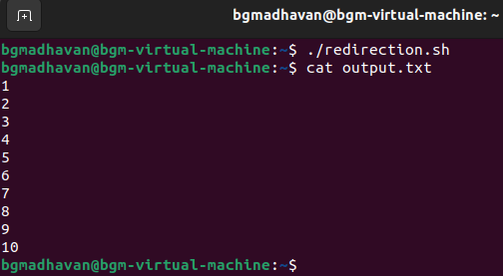

3) Create a text file with some content like your name, address.

4) Redirect the content to a new file.

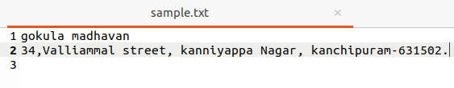

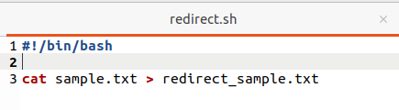

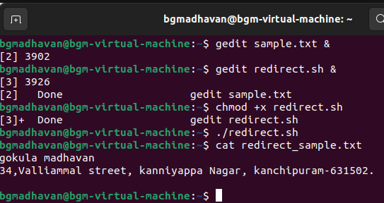

More on Redirection

1) Create X_file.txt file with some content.

2) Redirect the content of both out_file.txt and X_file.txt to a new file

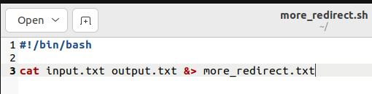

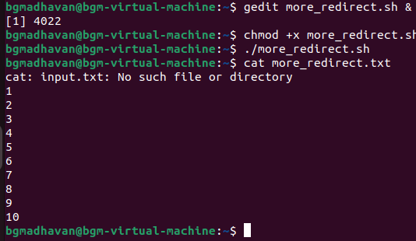

Here document and Here string

1) Convert a string to uppercase using:

a) Here document

b) Here string

Hint: tr a-z A-Z

